Hierarchical Clustering

**Short note about Hierarchical Clustering**:

**Hierarchical Clustering** (also called **hierarchical cluster analysis** or **HCA**) is a method of [cluster analysis](https://en.wikipedia.org/wiki/Cluster_analysis) which seeks to build a [hierarchy](https://en.wikipedia.org/wiki/Hierarchy) of clusters.

Strategies for hierarchical clustering generally fall into two types:

* **Agglomerative**: This is a "bottom up" approach: each observation starts in its own cluster, and pairs of clusters are merged as one moves up the hierarchy.

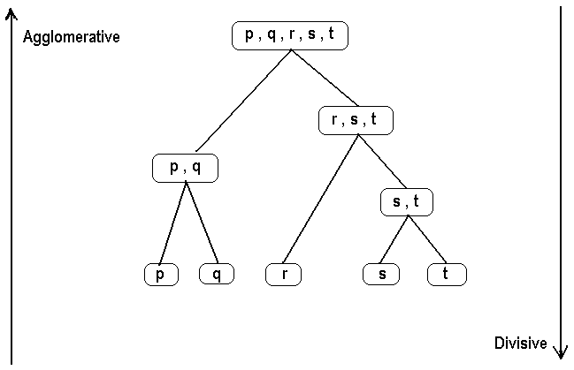

* **Divisive:** This is a "top down" approach: all observations start in one cluster, and splits are performed recursively as one moves down the hierarchy.

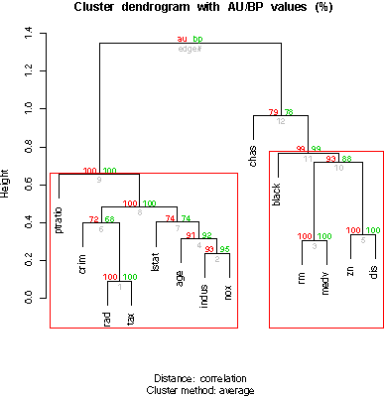

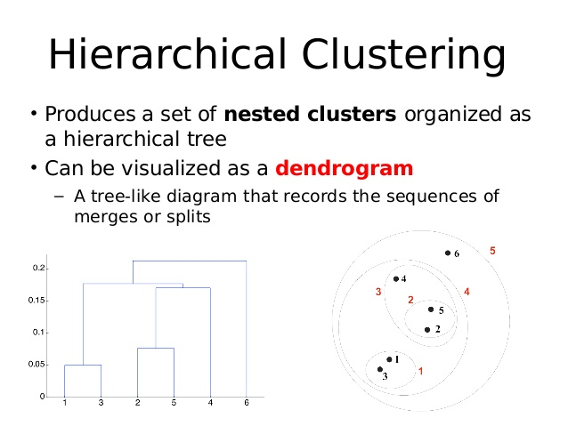

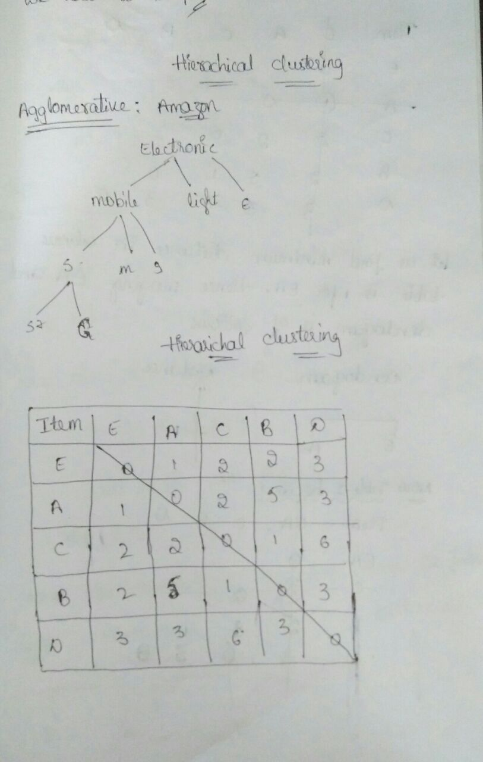

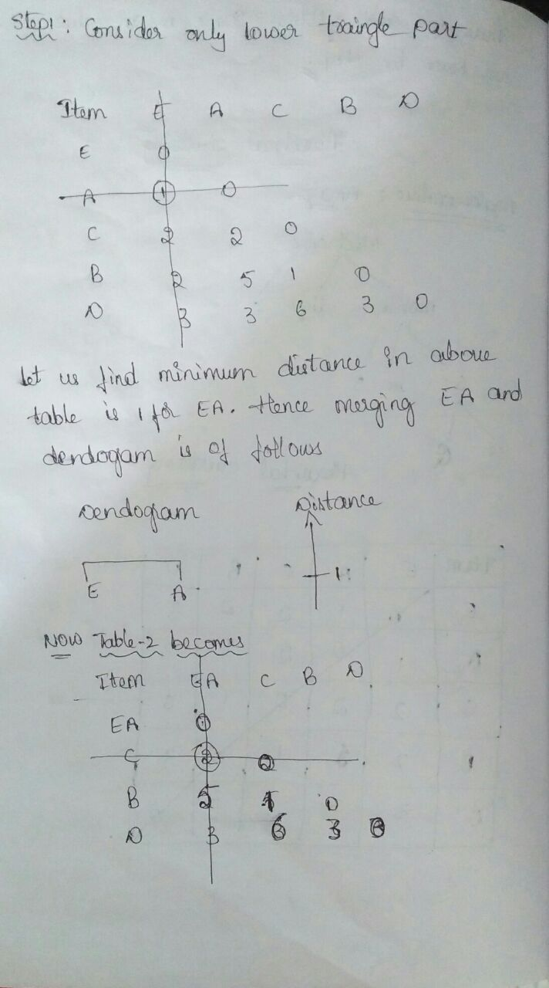

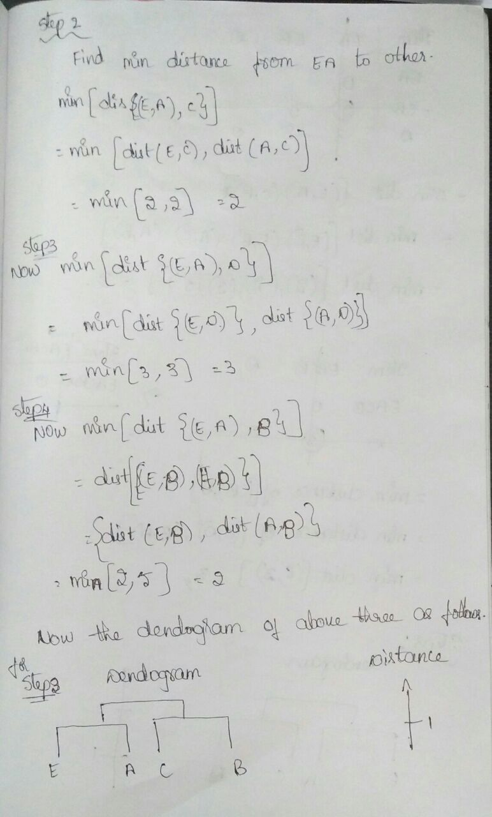

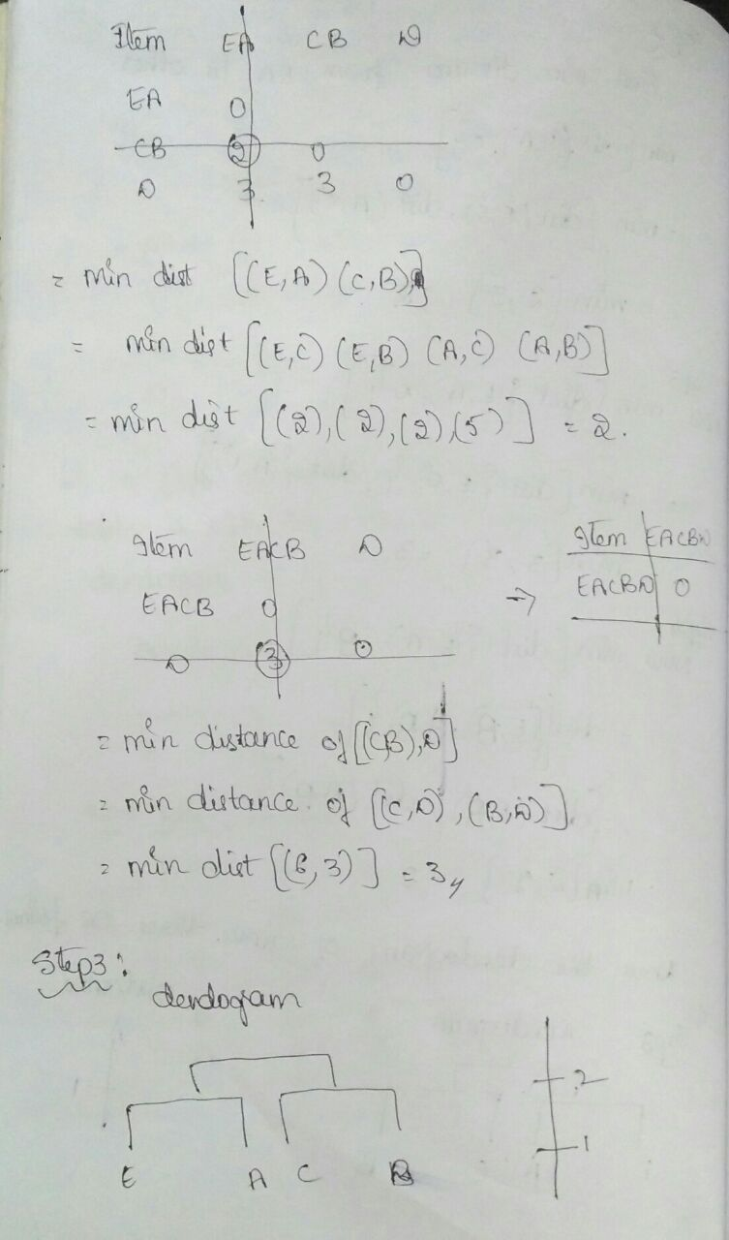

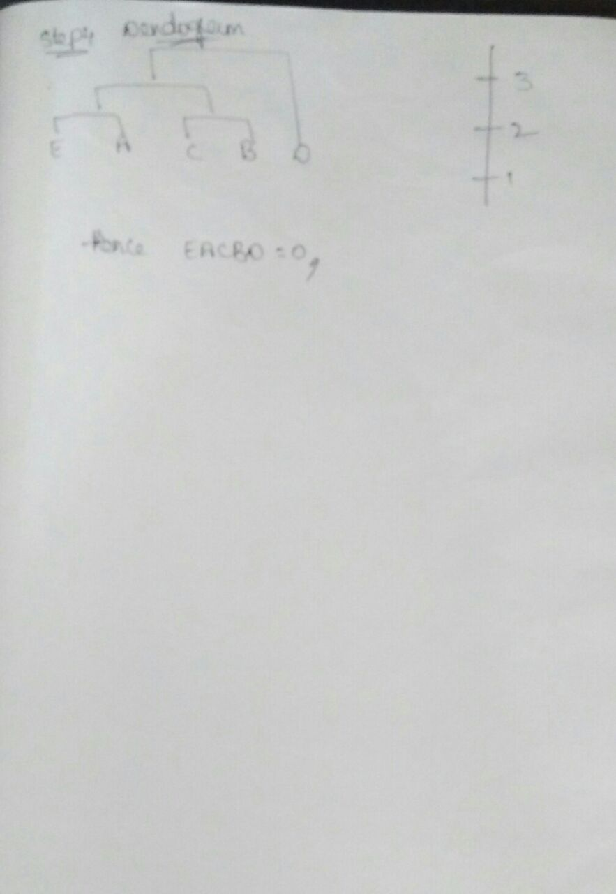

UseCases-

1. Finding the difference between approval of loan among Emp maximum and minimum salary.
2. Finding obese person with adiposity prone to heart disease
3. Finding Product Price & Sales
4. Finding Age & Mortality
5. Finding temperature vs. Number of cones sold at ice cream store
6. Finding Population vs Food consumption
7. Finding quantity with yield
8. Determining the chances to win cricket match .
9. Determining the chances of getting Jobs after Completing Graduation.
10. Speed and distance relationship
11. Finding rate of growth of the economy of a Institution

**Python-**

import numpy as np

import matplotlib.pyplot as plt

import pandas as pd

from scipy.cluster.hierarchy import linkage,dendrogram

import matplotlib.pyplot as plt

x=np.array([[1,1],[3,3],[4,4],[3,5],[1,1.5],[2,3.5]])

#plt.scatter(x[:,0],x[:,1],s=50)

#pltshow()

linkage_matrix=linkage(x,"single")

dendogram=dendrogram(linkage_matrix,truncate_mode='none')

plot.title("hierarichal clustering")

plt.show()

